KAMPALA JUNIOR ACADEMY – KITANTE
P.1 RELIGIOUS EDUCATION TERM I 2020

NAME: ___________________________________________STREAM: _______
1. My religious name is ________________________
2. I am a/ an __________________________________________
3. This is a _______________________

It was created by _____________________________
The sun gives us ______________and _________________
(bags, light, ice cream, heat)
4. Name these things that give us light.
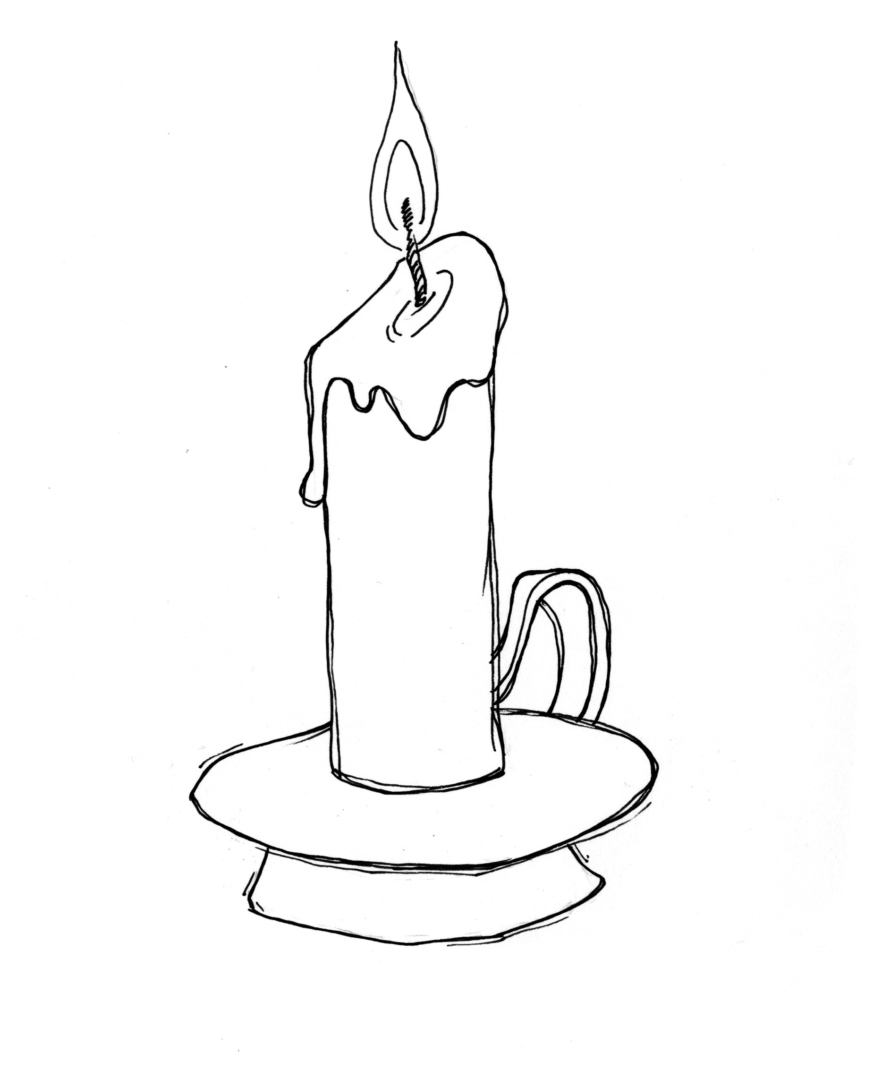 | 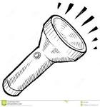
(moon, candle, torch)
5. Who died on the cross for our sins?
_____________________________________________________
6. Moslems go to the Mosque for Juma prayers on
________________________________
7. How many times do Moslems pray a day?
______________________________________________________
8. What is your religious name?
______________________________________________________

9. Draw the following people who work at school.
Nurse | Teacher | Cook

10. __________________was the mother of Jesus. (Mary, Rose)
11. Name these things we use to clean our body gifts from Go.


12. Mention any three body gifts.
i) ____________________ (ii) _____________________
(iii) ____________________
13. Write any two Christian names.
i) __________________________ (ii) _________________________
14. Name any two needy people.
i) __________________________ (ii) _________________________
15. Write down any two ways of keeping our body parts clean.
i) ________________________________________________________
ii) _______________________________________________________
16. Match correctly.
lame can not see
blind can not walk
poor can not hear
deaf has no money

17. Why do we keep our body clean?
i) _______________________________________________________
ii) _______________________________________________________
18. Draw these things created by God /Allah.
people | plants | stones

19. Underline three ways of respecting people.
by abusing by greeting by beating
by listening to them by obeying them
20. Who is the heavenly father of Jesus?
_________________________________________________________
21. Which body part is used for tasting?
_________________________________________________________
22. Christians go for prayers on __________________as Muslims go for prayers on _______________________
23. Draw these places of worship.
Church | Mosque

24. Give two uses of water.
i) ______________________________________________________
ii) _______________________________________________________
25. The main natural source of water is _______________________
26. This is the ___________________________
It gives us ___________________________
It dries our ____________________________
(clothes, light, sun)
27. Write 3 Moslem names for boys and girls.
Boys Girls
___________________ ____________________
___________________ ____________________
___________________ ____________________
28. What is the role of children in a family?
_______________________________________________________
29. Why do we pray?
_______________________________________________________

30. Give two reasons why we keep our body parts clean?
i) _________________________________________________
ii) _____________________________________________________
31. Match the leaders to the people they lead.
Pastor Moslems
Priest Protestants
Imam Catholics
Reverend Born again Christians

32. A Bible is to Christians while a __________________is to Moslems.

